**WEEK 2**  
  
**Advanced SQL**

**Create DB and Employees table (Setup for all SQL exercise)**

**CODE**CREATE DATABASE Week2TrainingDB;

GO

USE Week2TrainingDB;

CREATE TABLE Employees (

EmployeeID INT PRIMARY KEY IDENTITY(1,1),

FirstName NVARCHAR(50),

LastName NVARCHAR(50),

Department NVARCHAR(50),

Salary INT

);

INSERT INTO Employees (FirstName, LastName, Department, Salary) VALUES

('John', 'Doe', 'IT', 60000),

('Jane', 'Smith', 'HR', 55000),

('Alex', 'Brown', 'IT', 70000),

('Mary', 'Jones', 'Finance', 75000),

('Steve', 'Clark', 'Finance', 65000);

SELECT * FROM Employees;

**OUTPUT  
  
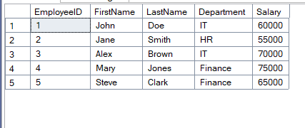**

**Exercise 1: Ranking and Window Functions  
  
CODE**

WITH SalaryCTE AS (

SELECT

FirstName,

LastName,

Department,

Salary,

ROW_NUMBER() OVER (PARTITION BY Department ORDER BY Salary DESC) AS RowNum,

RANK() OVER (PARTITION BY Department ORDER BY Salary DESC) AS RankNum,

DENSE_RANK() OVER (PARTITION BY Department ORDER BY Salary DESC) AS DenseRankNum

FROM Employees

)

SELECT * FROM SalaryCTE;  
  
  
**OUTPUT**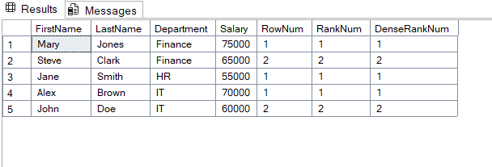

**Exercise 1: Create a Stored Procedure & Exercise 5: Return Data from a Stored Procedure & Exercise 4: Execute a Stored Procedure**

**CODE**

CREATE PROCEDURE GetEmployeesByDepartment

@Dept NVARCHAR(50)

AS

BEGIN

SELECT FirstName, LastName, Salary

FROM Employees

WHERE Department = @Dept;

END;

-- Execute it:

EXEC GetEmployeesByDepartment @Dept = 'Finance';

**OUTPUT**

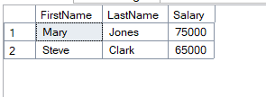

1. **SQL Exercise - Index**

**CODE**

CREATE NONCLUSTERED INDEX IX_Department_Salary

ON Employees(Department, Salary)

WITH (FILLFACTOR = 90);

-- Test the view

SELECT

name,

type_desc,

fill_factor

FROM sys.indexes

WHERE object_id = OBJECT_ID('Employees');

**OUTPUT**

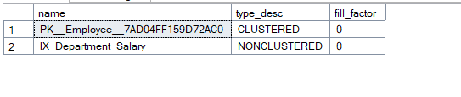

1. **SQL Exercise - Functions & Exercise 7: Return Data from a Scalar Function**

**CODE**

CREATE FUNCTION CalculateBonus (@Salary INT)

RETURNS INT

AS

BEGIN

RETURN @Salary * 10 / 100;

END;

-- Use it in a query

SELECT FirstName, LastName, Salary, dbo.CalculateBonus(Salary) AS Bonus

FROM Employees;

**OUTPUT**

